HANOI UNIVERSITY OF SCIENCE AND TECHNOLOGY

**SCHOOL OF ELECTRICAL AND ELECTRONIC ENGINEERING**



**PROJECT REPORT**

**(Tên dự án)**

Name of students: Class code: 165584 *–* Team 10

Mai Trung Hieu – 202514572

Nguyen Gia Vu – 202514624

Name of instructors: (Chức vụ) Tran Thi Thanh Hai

(Chức vụ) Tran Thi Thao Anh

Hanoi, 01/2026

Table of Contents

LIST OF FIGURES iv

LIST OF TABLES v

ACKNOWLEDGEMENT vi

ABSTRACT vii

1. Introduction 8

1.1. Motivation 8

1.2. Objectives 8

1.2.1. Main objectives 8

1.2.2. Specific objectives 9

2. Methodology 9

2.1. State of the art 9

2.1.1. Methods for web VR 9

2.1.2. Existing products for web VR 10

2.1.3. Dicussions 11

2.2. Application of the 9 steps in engineering design process 12

3. Project implementation 12

3.1. Step 1: User requirement 12

3.2. Step 2: Specifications 15

3.2.1. Functionality 15

3.2.2. Non functinality 15

3.3. Step 3: Planning 16

3.4. Step 4: Block Design 17

3.5. Step 5: Detail block design 18

3.6. Step 6: Best altenatives selection 19

3.7. Step 7: Prototyping 19

3.8. Step 8: Testing 20

4. Discussions 25

5. Conclusions and future works 26

6. Reference 27

# LIST OF FIGURES

Figure 1.１: Objective and specific objectives 9

Figure 2.１: Steps of the Engineering Design Process 12

Figure 3.１: Chart of difficulties faced by users 13

Figure 3.２: Chart of popularity of VR technology among users 13

Figure 3.３: Chart of users’ interest in VR technology 14

Figure 3.４: Chart of functions favored by users 14

Figure 3.５: Chart of devices popular among users 15

Figure 3.６: Main blocks of our proposed system 17

Figure 3.７: Flow chart 18

Figure 3.８: High-Fi Prototyping 19

Figure 3.９:Discrete graphics card's framerate stability 21

Figure 3.１０: Integrated graphics card's framerate stability 21

Figure 3.１１: Resource utilization of discrete graphics card 22

Figure 3.１２: Resource utilization of integrated graphics card 22

# LIST OF TABLES

Table 2.1: Summary of existing products 10

Table 3.1: Summary of the main functions of our proposed system 16

Table 3.2: Timeline of the project 17

Table 3.3: Summary of tasks and subtasks distrubution 17

Table 3.4: Comparison of the server 19

Table 3.5: Comparison of the 3D rendering 19

Table 3.6: Summary of testing result 23

# ACKNOWLEDGEMENT

The successful completion of the HUST Virtual Tour project would not have been possible without the invaluable guidance and support of several individuals.

First and foremost, we express our deepest gratitude to Assoc. Prof. Pham Van Tien for his unwavering encouragement and insightful feedback. His expertise and leadership created the perfect environment for our team to explore innovative ideas and execute them effectively.

We are equally indebted to Assoc. Prof. Tran Thi Thanh Hai, whose thoughtful advice and constructive critiques significantly enriched the quality of our project. Her dedication to fostering academic excellence and attention to detail inspired us throughout this journey.

Despite our best efforts, we acknowledge the limitations of our abilities and the novelty of this field for our team. Inevitably, there might be areas for improvement in both content and presentation. We warmly welcome further guidance from Assoc. Prof. Pham Van Tien, Assoc. Prof. Tran Thi Thanh Hai, and additional suggestions from others to refine this project.

Lastly, we extend our heartfelt thanks to everyone who contributed their time, knowledge, and resources to support us in making the HUST Virtual Tour a reality.

# ABSTRACT

As the need for accessible and immersive campus experiences increases, the HUST Virtual Tour project aims to provide a cutting-edge solution for prospective students and visitors. This project is designed to simulate a comprehensive exploration of Hanoi University of Science and Technology through advanced technologies, including 360-degree images, virtual reality (VR), and AI chatbot. The system is designed based on common user needs to meet usability and standards, offering access via multiple platforms. The development process is presented in this report. The HUST Virtual Tour successfully fulfills its primary objectives, providing an innovative alternative to physical campus visits. However, further enhancements are recommended to expand its features and ensure continuous improvement in user experience.

# Introduction

## Motivation

Navigating university campuses can be a daunting task for freshmen and visitors, especially at large institutions like Hanoi University of Science and Technology (HUST). Many prospective students and their families are unable to visit the campus in person due to geographical or logistical challenges, limiting their understanding of the university's environment, facilities, and resources. Additionally, new students often struggle with orientation during their initial weeks, leading to stress and inefficiency in navigating the campus.

Recognizing these challenges, the HUST Virtual Tour project was initiated to address these limitations. By leveraging modern technologies such as 360-degree images, virtual reality, and AI chatbot, the project aims to provide an immersive, user-friendly alternative for exploring the campus remotely. This initiative not only enhances the accessibility of campus information but also serves as an innovative tool for improving the university’s engagement with prospective students and easing the transition for new enrollees.

## Objectives

### Main objectives

Design a website which creates an accessible and interactive virtual platform that allows users to explore Hanoi University of Science and Technology effectively.

Figure .: Objective and specific objectives

### Specific objectives

Ensure accessibility anytime, anywhere across multiple platforms: Develop the virtual tour to be accessible 24/7 on a variety of platforms, including web browsers, Android, and iOS devices. This ensures that users can explore the campus conveniently from any location and on their preferred devices, with seamless functionality across different operating systems.

Provide free access to users: Design the virtual tour to be completely free of charge, ensuring that all prospective students, visitors, and current users can explore the campus without any financial barriers. This objective emphasizes inclusivity and encourages widespread engagement with the platform.

# Methodology

## State of the art

### Methods for web VR

In developing the HUST Virtual Tour, we utilized modern web technologies and frameworks to create an interactive and immersive experience. The system incorporates both 2D functions and 3D scenes to provide a dynamic and visually engaging platform.

For the 2D functions, we employed **HTML, CSS, and JavaScript**, enabling the design and implementation of responsive layouts, intuitive user interfaces, and seamless user interactions. These technologies ensured a consistent and accessible experience across various devices and screen sizes.

To render 3D scenes, we adopted **A-Frame**, a powerful WebVR framework based on HTML. A-Frame facilitated the creation of immersive 3D environments directly in the browser, making it highly suitable for building interactive virtual tours. Additionally, we leveraged **WebXR** to enhance compatibility with virtual and augmented reality devices, ensuring that the tour can be experienced in an immersive format on supported hardware. [1]

### Existing products for web VR

Table .: Summary of existing products

|  |  |  |  |
| --- | --- | --- | --- |
| Product | Main features | Advantages | Drawbacks |
| University of Technology Sydney (UTS) Virtual Tour[1] | * Immersive 360-degree views * Interactive navigation through various university facilities. * Informative descriptions of key locations and buildings. | 😊User-friendly interface with easy navigation.  😊Free access without requiring user registration.  😊Tailor to users experiments  😊Allow users to choose specific tours | ☹ Low resolution 360-degree videos |
| Harvard University Virtual Tour[2] | * Interactive map with 360-degree views * Student-led video narratives providing personal insights. * Information on buildings and facilities. | 😊 Mobile-friendly interface for on-the-go exploration.  😊Engaging storytelling from current students.  😊No cost or login requirements for access. | ☹ Limited customization based on individual interests.  ☹ May not include the latest campus developments or renovations. |
| Vietnam Military History Museum[3] | * 360-Degree Panoramic Views * Informative descriptions about exhibits and locations. * Interactive navigation through various exhibition areas | 😊 Interactive hotspots enhance learning by providing detailed information about each artifact.  😊Free access without requiring user registration. | ☹ Does not support multiple language  ☹ No instructions for users |

### Dicussions

From existing products, we aim to create a similar solution tailored for Hanoi University of Science and Technology. Our goal is to enhance the strengths of current offerings, such as free access without requiring user registration, voice descriptions, and a user-friendly interface with easy navigation. At the same time, we address limitations by providing clear instructions and guidance for users and supporting multiple languages, including Vietnamese, Chinese, and English. Our website allows users the freedom to customize their tour routes based on their preferences, instead of following a predefined itinerary.

## Application of the 9 steps in engineering design process

Figure .: Steps of the Engineering Design Process

# Project implementation

## Step 1: User requirement

A small survey was conducted with participants including HUST students, high school students, parents, and others. The survey results revealed that 72.7% of respondents faced difficulties navigating and locating buildings within the campus. Notably, 81.8% of those who encountered this issue were HUST students themselves, who are expected to be the most familiar with the campus. This highlights the urgency of addressing this problem. Additionally, 60.8% of high school students and parents expressed concerns about verifying the accuracy of information and the facilities available at the university. To tackle these challenges, our team initiated the HUST Virtual Tour project, leveraging 360 VR technology to facilitate virtual campus exploration.

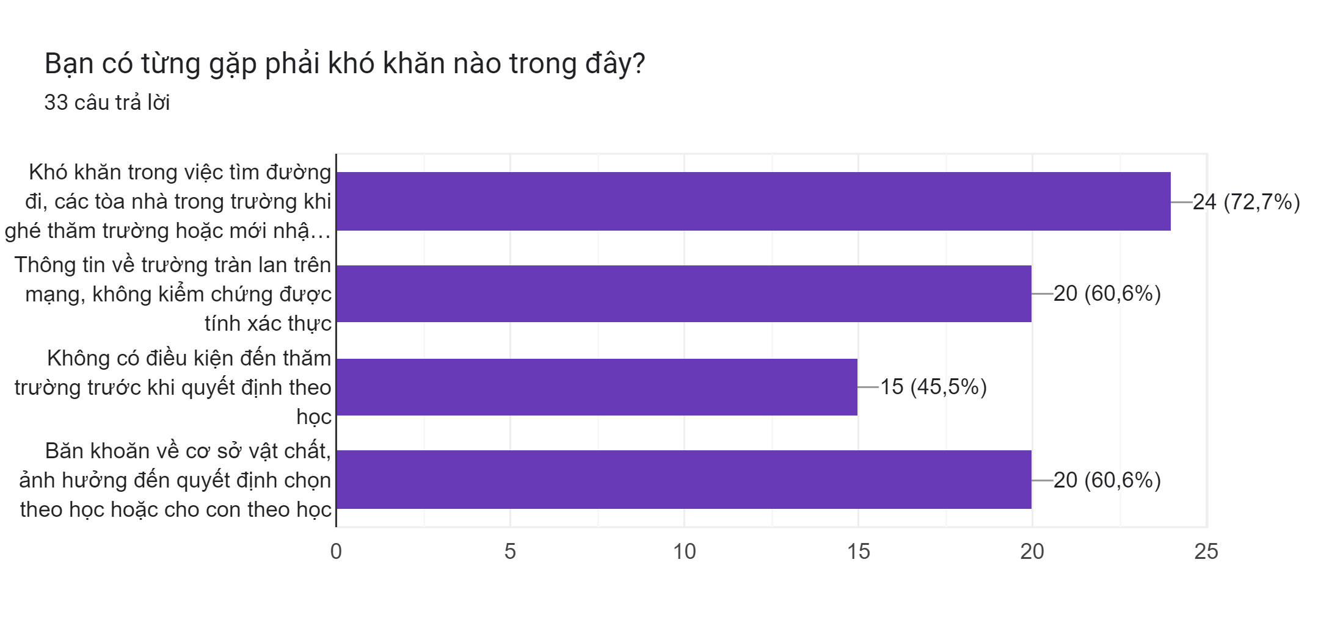

Figure .: Chart of difficulties faced by users

We also carried out a survey to assess the awareness of VR technology among users. The results revealed that nearly half of the respondents were unfamiliar with 360 VR technology, which is a relatively high percentage. However, 93.3% of participants expressed interest in using a virtual campus tour website incorporating this technology, even though they had little a understanding of it. This indicates the project's potential for development and the likelihood of positive user reception if implemented.

Biểu đồ câu trả lời của biểu mẫu. Tên câu hỏi: Bạn có biết về công nghệ 360VR (virtual reality) trong việc tham quan trường học không?
. Số lượng câu trả lời: 30 câu trả lời.

Figure .: Chart of popularity of VR technology among users

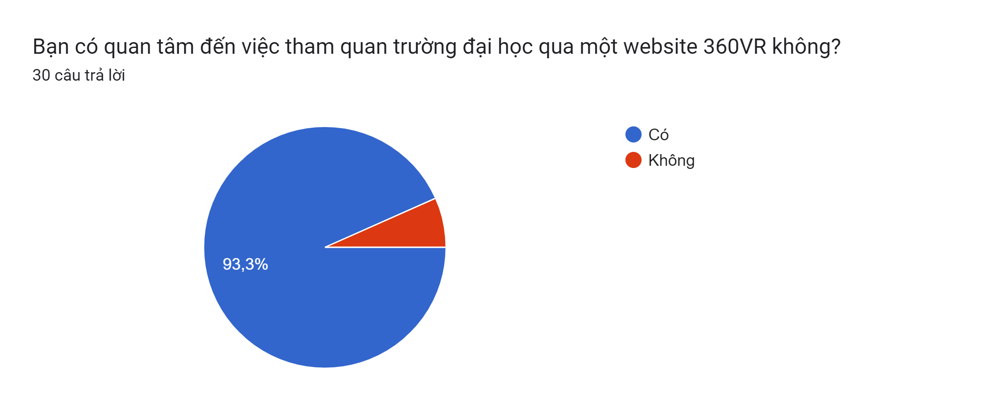

Figure .: Chart of users’ interest in VR technology

Users showed the most interest in features that allow them to click on locations for detailed area information. As a result, this has been selected as the primary feature for development.

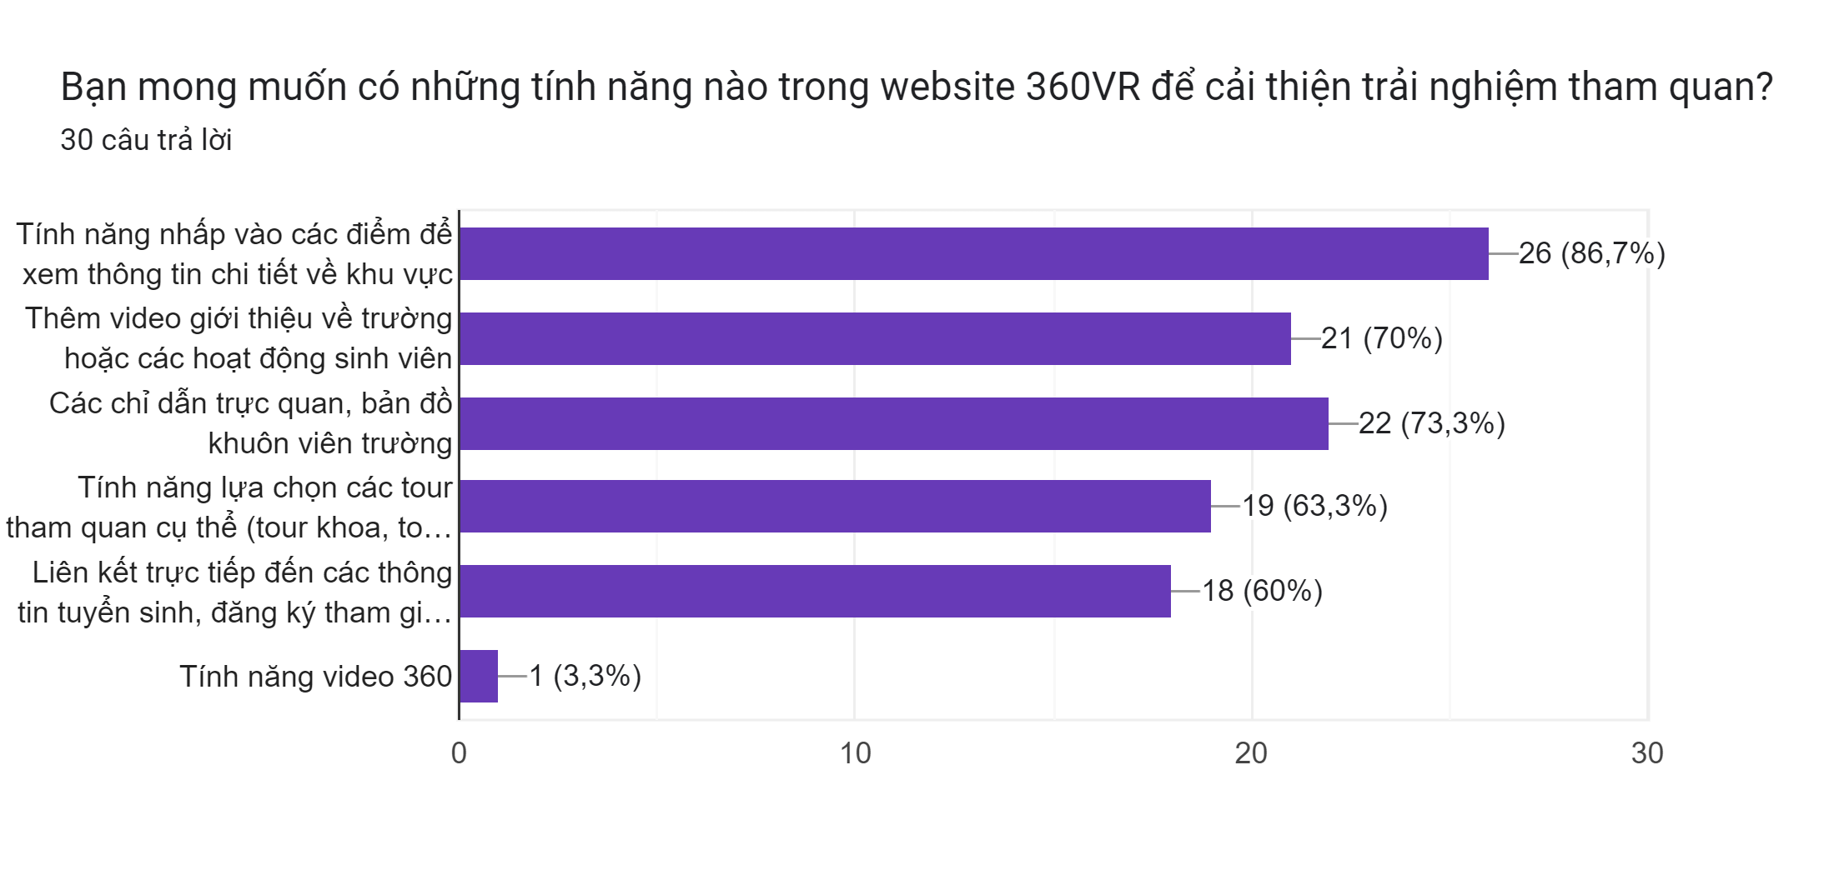

Figure .: Chart of functions favored by users

90% of respondents prefer accessing the VR website via computer, so we prioritize optimizing the desktop user interface.

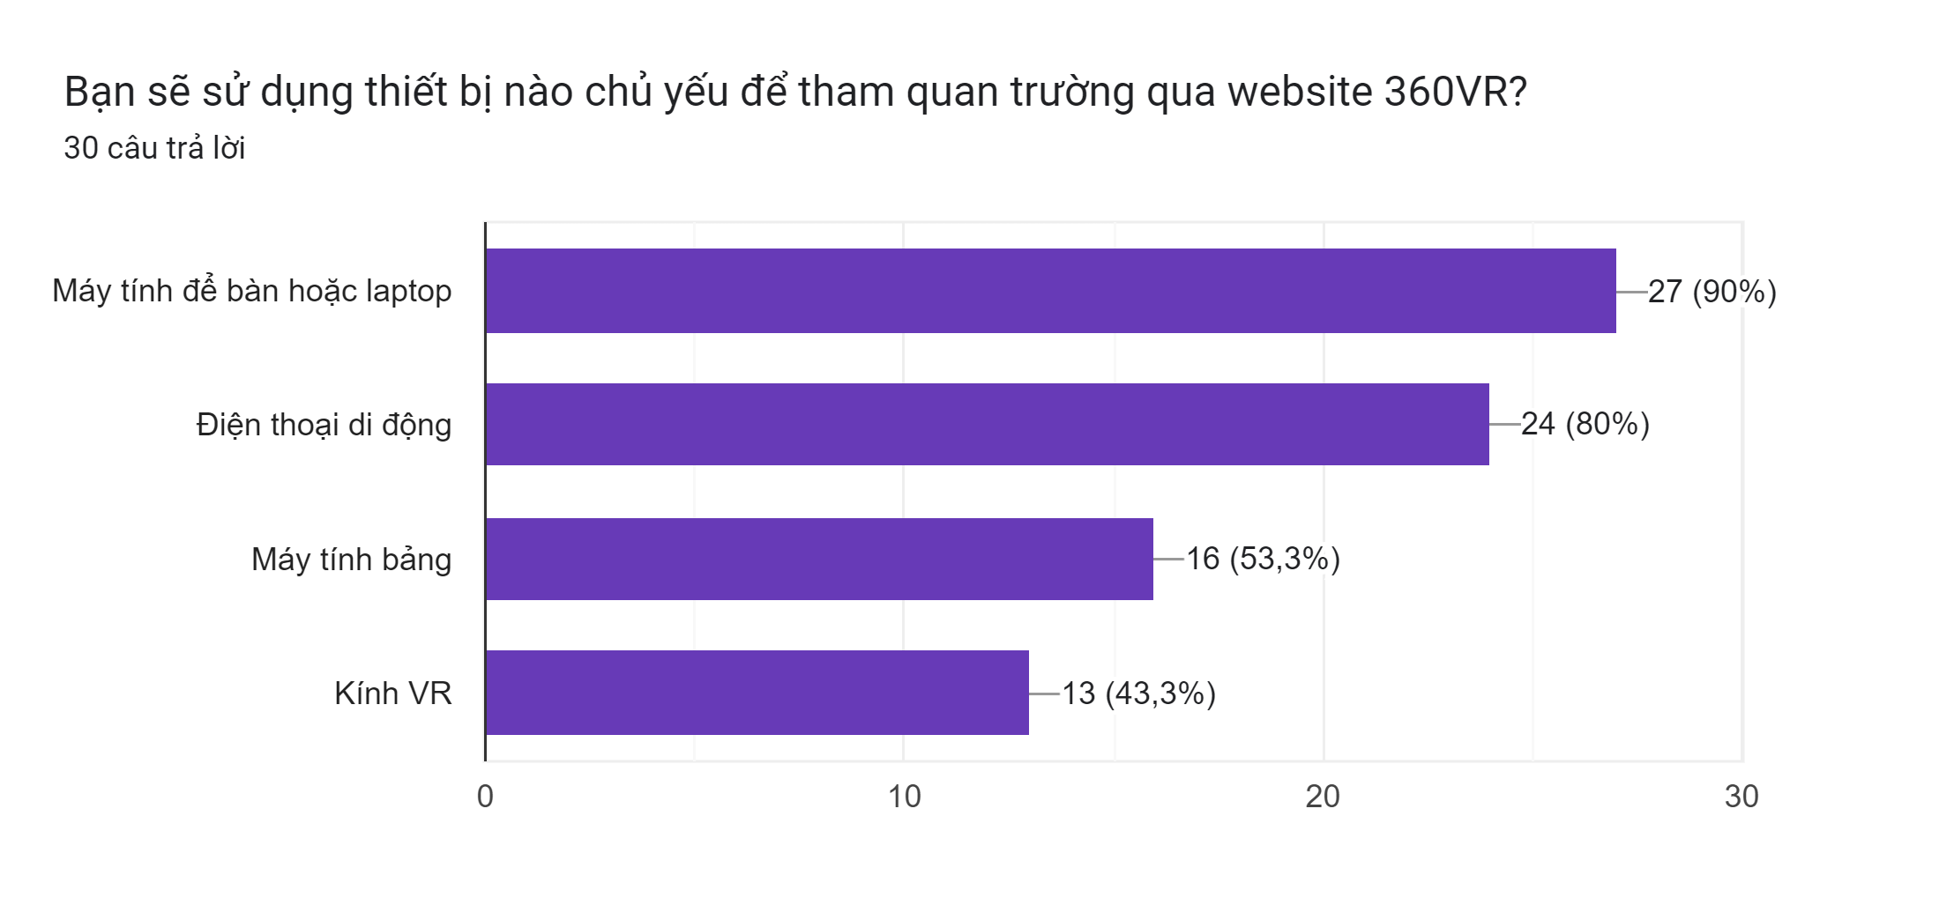

Figure .: Chart of devices popular among users

­

## Step 2: Specifications

### Functionality

Function 1: AI chatbot [2]

API Gemini Flash 1.5

* Input: Text
* Output: Corresponding responses display in text

Function 2: Navigation to different location

* Input: Click/Press
* Output: Next corresponding scene

Function 3: Audio and text description

* Input: Click/Press
* Output: Audio played for voice description and Text displayed for text description

### Non functinality

Non- Function 1: For AI chatbot [3]

* 15 RPM: handle 15 requests per minute.
* 1 million TPM: supports up to 1 million transactions per month.
* 1,500 RPD: process up to 1,500 requests per day.

Non- Function 2: For navigating to different location

* Speed render: 60 – 140 frames/ second
* Allow free roam

Non- Function 3: For audio and text description

* Support 3 languages: Vietnamese, English and Chinese
* Display text and audio to users’ preference

Table .: Summary of the main functions of our proposed system

|  |  |  |
| --- | --- | --- |
| Function | Description of the function | Priority |
| Navigation | Enables users to explore the HUST campus virtually by selecting locations of interest on an interactive 3D map. | Required |
| Voice and Text description | Offers detailed descriptions of campus facilities and landmarks in both voice and text formats in multiple languages. | Required |
| AI chatbot | Acts as a virtual assistant to answer user queries, providing real-time, personalized support and enhancing the virtual tour experience. | Optional |

## Step 3: Planning

Put the figure showing the tasks, subtasks, the person in chages, the timelines

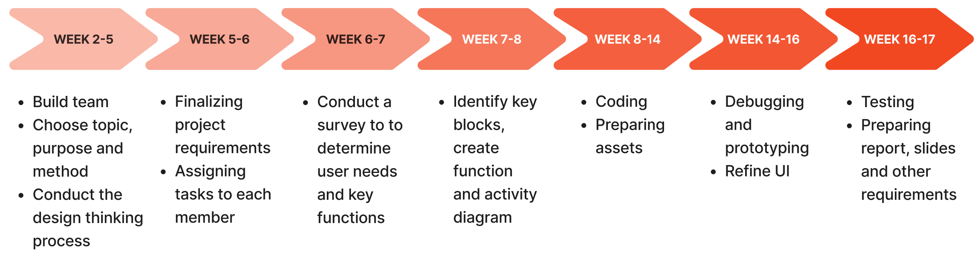

Table .: Timeline of the project

Table .: Summary of tasks and subtasks distribution

## Step 4: Block Design

HTTP Request

WEB BROWSER

WEB SERVER

Display Response Data

HTTP Response

HTML, CSS, JS files

Click/Press

Figure .: Main blocks of our proposed system

## Step 5: Detail block design

Figure .: Flow chart

## Step 6: Best altenatives selection

Table .: Comparison of the server

|  |  |  |  |
| --- | --- | --- | --- |
| Item | Price | Reliability | Performance |
| Amazon web service (AWS) [4] | $5 - $20/month  (small-scale project) | High | High |
| Microsoft Azure [5] | ~ $29/month  (for developer) | High | High |

Table .: Comparison of the 3D rendering

|  |  |  |  |
| --- | --- | --- | --- |
| Item | Price | Reliability | Performance |
| React VR | Free | High | High |
| Babylon.js | Free | High | High |

## Step 7: Prototyping

Figure .: High-Fi Prototyping

1. After choosing the appropriate language, a 3D guide will appear and present to the users the instructions. Along with it, a 2D menu including functions such as chatbot, photo gallery display, information booth, languages will appear.
2. In the 3D scene, there are yellow (back, forward, left, right) arrows that allow the users to navigate around different locations.
3. In some noticeable scenes, there is an info button that enables the users to inquire about the destination in either voice or text. Additionally, the users can also change the language to their likings; however, this requires them to restart their process

Overall, all main functions have worked properly with some minor bugs in the navigation feature that may cause the users to reach the wrong destination.

## Step 8: Testing

**Main Factors Affecting the Product:**

The performance of the HUST Virtual Tour is primarily influenced by hardware configuration, including GPU and CPU capabilities, memory usage during rendering, and load time for assets. Framerate stability, resource utilization, and load time are critical factors for ensuring a smooth user experience.

**Testing Scenario:**

We conducted testing on two hardware configurations to evaluate the product's performance under different conditions:

* Discrete Graphics Card Setup: Intel Core i5 CPU paired with NVIDIA GeForce RTX 3050 GPU.
* Integrated Graphics Card Setup: AMD RYZEN 5000-U

The test scenarios included navigation through scenes, rendering transitions, load time for assets, and overall system stability under both local Wi-Fi and constrained bandwidth conditions.

**Conducting the test:**

For the discrete graphics card setup (Intel Core i5 + NVIDIA RTX 3050), framerate, memory usage, and load time were measured during normal navigation and scene transitions. Similarly, the integrated graphics setup (AMD RYZEN 5000-U) was tested under the same scenarios. Load time was measured on a local Wi-Fi network and under constrained bandwidth to evaluate network dependency.

**Analyzing the Test Results:**

Framerate: On the discrete GPU setup (Intel Core i5 + NVIDIA RTX 3050), the framerate ranged between 100–140 fps, demonstrating high stability across navigation and transitions. In contrast, the integrated GPU setup (AMD RYZEN 5000-U) maintained a peak framerate of 60 fps but experienced frequent frame drops, especially during scene transitions, which affected the overall user experience.



Figure .:Discrete graphics card's framerate stability

Không có mô tả.

Figure .: Integrated graphics card's framerate stability

Render Performance: The discrete GPU setup efficiently utilized dual GPU rendering, keeping memory usage at 50% and RAM usage at 60%, enabling smooth and reliable performance. Conversely, the integrated GPU setup required rendering with both the CPU and GPU, leading to higher resource consumption with RAM usage at 90%, which caused occasional lags and reduced performance stability.

Load Time: On a local Wi-Fi network, the discrete GPU setup loaded all assets in 31.14 seconds, while the integrated GPU setup required 39.26 seconds. However, under constrained bandwidth, both setups faced timeout errors when attempting to load assets, highlighting a limitation in network dependency and scalability.

Resource Utilization: For both hardware setups, the majority of resources were spent on scripting. However, the discrete GPU setup (Intel Core i5 + NVIDIA GeForce RTX 3050) managed to avoid consistently reaching maximum CPU capacity, ensuring smoother performance. In contrast, the integrated GPU setup (AMD RYZEN 5000-U) often pushed the CPU to its limits, reducing overall efficiency and contributing to occasional performance drops.

Figure .: Resource utilization of discrete graphics card

Figure .: Resource utilization of integrated graphics card

Table .: Summary of testing result for laptop

|  |  |  |
| --- | --- | --- |
| **Factors** | **Discrete graphics card** | **Integrated graphics card** |
| Framerate | * 100–140 fps * high stability | * peaked at 60 fps * frequent frame drops |
| Render performance | * 50% memory usage and 60% RAM usage | * 90% RAM usage |
| Loadtime | * Local Wi-Fi network: 31.14 seconds. * Constrained bandwidth: timeout error | * Local Wi-Fi network: 39.26 seconds. * Constrained bandwidth: timeout error |
| Resource utilization | * The majority of resources were spent on scripting * CPU did not consistently reach maximum capacity | * The majority of resources were spent on scripting * CPU frequently operated at maximum capacity |

**Testing between devices:**

Table .: Summary of testing results between devices

|  |  |  |
| --- | --- | --- |
| **Devices** | Framerate | Ram usage |
| **VR headset**  **(Oculus Quest 2)** | * 60 – 70 fps * Low stability at first but gradually improve | 60% RAM usage |
| **Samsung Galaxy S23 Ultra**  **(Snapdragon 8 gen2)** | * 60 – 70 fps * Low stability at first but gradually improve | 60% RAM usage |
| **Laptop** | * 60 – 140 fps |  |

# Discussions

Despite its promising features, the HUST Virtual Tour project has some limitations that need addressing. Firstly, the tour does not provide a complete view of the entire campus, limiting its coverage. This partial scope restricts users from exploring all areas of interest.

Secondly, the project lacks an overall map feature, which would help users gain a comprehensive understanding of the campus layout and enhance their navigation experience.

Additionally, while the project supports multiple languages, it does so by creating separate web versions for each language, lacking an automatic translation function. This approach increases maintenance complexity and may hinder scalability.

Obtaining assets, such as 360-degree images and 3D models, can be time-consuming, which delays updates and the inclusion of new content.

There are also occasional bugs in the navigation features, which may affect the user experience and require refinement to improve reliability.

Lastly, the project is not yet hosted on a public domain due to time constrain, restricting its accessibility to a wider audience.

# Conclusions and future works

In conclusion, the HUST Virtual Tour project successfully achieves its primary objective of creating an accessible and interactive platform for users to explore Hanoi University of Science and Technology. The website provides navigation, voice and text descriptions, and an AI chatbot, ensuring accessibility across multiple platforms. However, it cannot yet be assessed anytime and anywhere. Additionally, it offers free access to users under certain conditions stated in the instructions

Despite these accomplishments, the project has limitations, such as incomplete campus coverage, reliance on separate language-specific web versions instead of automatic translation, and occasional navigation bugs. To address these issues, future improvements will focus on expanding campus coverage, integrating real-time translation features, enhancing system reliability, and hosting the platform on a public domain. These efforts aim to make the HUST Virtual Tour more comprehensive and user-friendly.

# Reference

1. *A-FRAME* from <https://ai.google.dev/pricing#1_5flash>
2. *Google AI for Developers, Gemini API docs* from <https://ai.google.dev/gemini-api/docs>
3. *Google AI for Developers, Pricing* from <https://ai.google.dev/pricing#1_5flash>
4. *AWS* from [https://aws.amazon.com/free](https://aws.amazon.com/free/?gclid=EAIaIQobChMIsuO_6-LWigMV1OwWBR1dHjs1EAAYASAAEgJyfPD_BwE&trk=c4f45c53-585c-4b31-8fbf-d39fbcdc603a&sc_channel=ps&ef_id=EAIaIQobChMIsuO_6-LWigMV1OwWBR1dHjs1EAAYASAAEgJyfPD_BwE:G:s&s_kwcid=AL!4422!3!637354294236!e!!g!!amazon%20web%20services!19043613274!143453611346&all-free-tier.sort-by=item.additionalFields.SortRank&all-free-tier.sort-order=asc&awsf.Free%20Tier%20Types=*all&awsf.Free%20Tier%20Categories=*all)
5. *Microsoft, Azure Pricing* from <https://azure.microsoft.com/en-us/>

1. <https://tour.uts.edu.au/>
2. <https://college.harvard.edu/admissions/explore-harvard/virtual-tour>
3. <https://vr360.yoolife.vn/bao-tang-lich-su-quan-su-viet-nam-zmuseumc118u26724>